
ECONOMICS

Unit 3, Outcome 2
School-Assessed Coursework (SAC) 2
Structured Questions: ‘Domestic Macroeconomic goals’

STUDENT NAME: ______________________________________________
READING TIME: 5 minutes
WRITING TIME: 60 minutes
QUESTION AND ANSWER BOOK
Structure of book
Section | Number of questions | Number of questions to be answered | Number of marks
A | 10 | 10 | 10
B | 3 | 3 | 30
Total |  |  | 40

Conditions and restrictions
• Students are permitted to bring into the room for this task: pens, pencils, highlighters,
erasers, sharpeners and rulers and a calculator.
• Students are NOT permitted to bring into the room for this task: blank sheets of paper
and/or white out liquid/tape.

Materials supplied
• Question and answer book of 17 pages
Instructions
• Print your name in the space provided on the top of the front page.
• All written responses must be in English.

Students are NOT permitted to bring mobile phones and/or any other unauthorised electronic communication devices into the room for this task
Section A: Multiple Choice Questions
Instructions for section A
Answer all questions in pencil on the answer sheet provided for multiple choice questions.
Choose the response that is correct or the best answers the question.
A correct answer scores 1, an incorrect answer scores 0.
Marks will not be deducted for incorrect answers.
No marks will be given if more than one answer is completed for any question.

Question 1
Which of the following would most likely decrease as a result of an upturn in the business (economic) cycle?
A. the rate of inflation
B. the level of economic activity
C. the level of imports
D. the rate of unemployment

Question 2
A decrease in business productivity will have which of the following effects on the economy?
A. An increase in general prices, increase in real GDP and a decrease in unemployment
B. A decrease in general prices, increase in real GDP and a decrease in unemployment
C. An increase in general prices, a decrease in real GDP and an increase in unemployment
D. An decrease in general prices, a decrease in real GDP and an increase in unemployment

Question 3
Consider the following related to the labour market of a hypothetical economy.
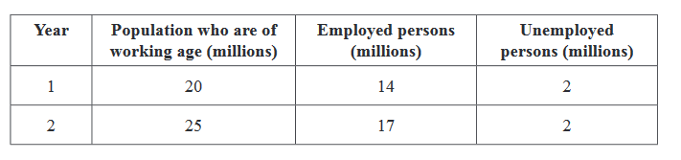
In comparing Year 2 to Year 1, which one of the following statements is true?

A. Year 2 has a lower participation rate and a lower unemployment rate.
B. Year 2 has a lower participation rate and a higher unemployment rate.
C. Year 2 has a higher participation rate and a lower unemployment rate.
D. Year 2 has a higher participation rate and a higher unemployment rate.

Question 4
Net exports in Australia is most likely to be increased by
A. a decrease in general prices (inflation)
B. an increase in domestic interest rates
C. a increase in the exchange rate
D. a fall in confidence in overseas markets

Question 5
Which of the following would be a negative consequence associated with high inflation?
A. Improvements in material living standards
B. Resource misallocation
C. Higher levels of household savings leading to higher household savings ratio
D. Higher levels of international competitiveness in Asian countries

Question 6
Which of the following is correct about the circular flow of income?
A. Increases in household consumption leads to higher leakages and a fall in real GDP growth.
B. A fall in government G2 expenditure on roads and hospitals will lead to higher injections and lower real GDP growth
C. A increase in the exchange rate may lead to improve international competitveness, higher injections and real GDP growth
D. A decrease in government income tax should lead to higher household consumption, higher injections and higher real GDP growth

Question 7
An increase in consumer confidence should have which effect on the domestic economy in Australia?
A. Aggregate Demand curve should shift to the right, general prices should rise and real GDP growth should rise
B. Aggregate Demand curve should shift left, general prices should fall and real GDP growth should fall.
C. Aggregate Demand curve should shift right, general prices should fall and real GDP growth should rise
D. Aggregate Demand curve should shift left, general prices should fall, and real GDP growth should fall

Question 8
Which of the following components of Aggregate Demand fluctuates the most?
A. Consumption
B. Investment
C. Net Exports
D. Government Expenditure

Question 9
The true extent of unemployment in Australia may be greater than indicated by the measure of the unemployment rate provided by the Australian Bureau of Statistics (ABS) because:
A. Only includes cyclical unemployment
B. Does not include those who are seeking part-time work.
C. does not include the unemployment of young people aged below twenty-one years.
D. does not include those who may have been discouraged from actively seeking work.

Question 10
Consider the following data for Country B.
 | 2015 | 2016 | 2017 | 2018
Consumer Price Index (CPI) | 100 | 103 | 105 | 104

Based on the information above, which one of the following statements is not true?
A. The country experienced deflation in 2018.
B. The country experienced deflation in 2017 and 2018.
C. Over the four-year period, the general level of prices rose.
D. The inflation rate in 2016 was higher than it was in 2017.

Section B – Short Answer questions (30 marks)

Inflation rate 2020 – present
7.8
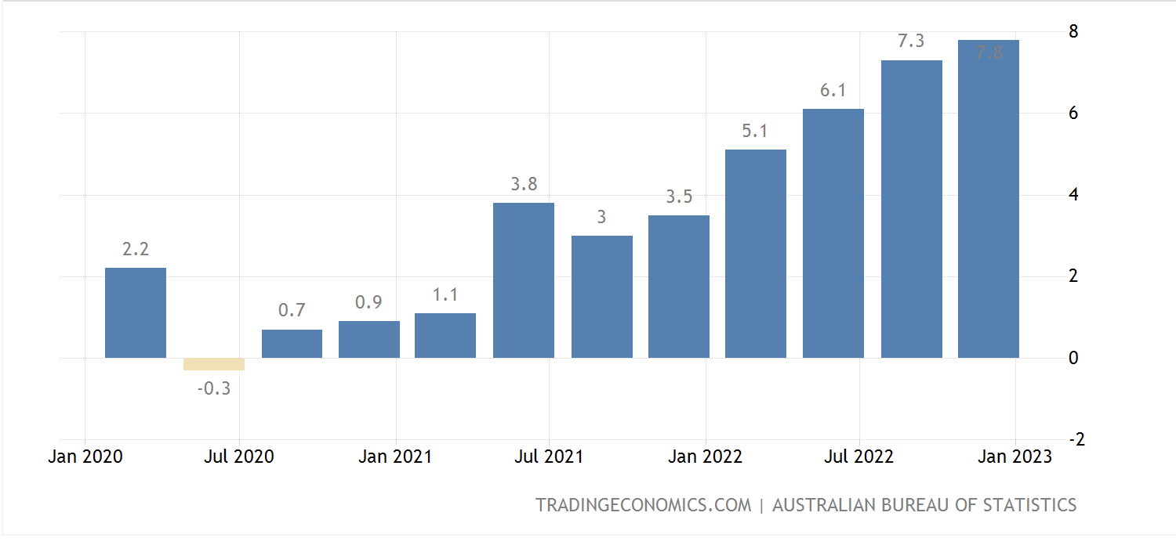

Question 1 (8 marks)
a. Describe the trend inflation rate since January 2021
2 marks
________________________________________________________________________________________________________________________________________________________________________________________________________________________________________________________________________________________________________________________________________

b. Describe one AD or one AS factor that has contributed to the trend in the inflation rate since 2021.
2 marks
________________________________________________________________________________________________________________________________________________________________________________________________________________________________________________________________________________________________________________________________________________________________________________________________________________________________________________________________________________________________________________________________________________________________________________________________________________________________________________________________________________

c. Identify and explain two consequences of high inflation.
4 marks
____________________________________________________________________________________________________________________________________________________________________________________________________________________________________________________________________________________________________________________________________________________________________________________________________________________________________________________________________________________________________________________________________________________________________________________________________________________________________________________________________________________________________________________________________________________________________________________________________________________________________________________________________________________________________________________________________________________________________________________________________________________________________________________________________________________________________________________________________________________________________________________________
Question 2 (13 marks)
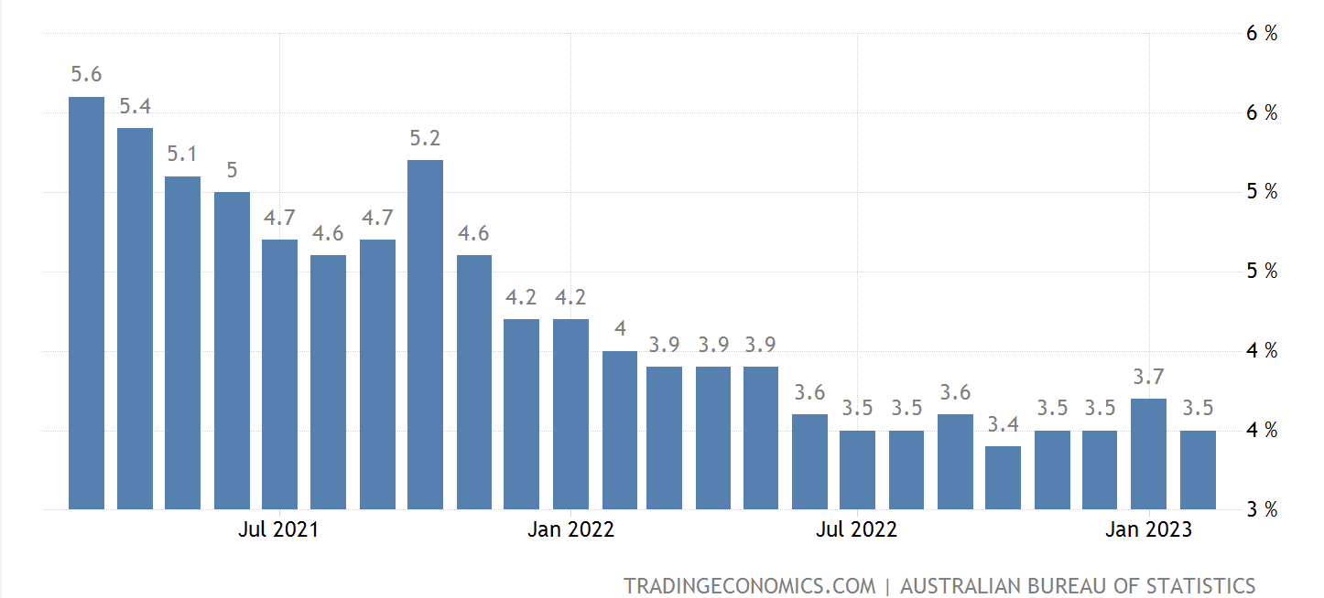

a. Evaluate the extent to which the economy has achieved the domestic macroeconomic goal of full employment over the past two years and discuss the effect of this on living standards.
6 marks
________________________________________________________________________________________________________________________________________________________________________________________________________________________________________________________________________________________________________________________________________________________________________________________________________________________________________________________________________________________________________________________________________________________________________________________________________________________________________________________________________________________________________________________________________________________________________________________________________________________________________________________________________________________________________________________________________________________________________________________________________________________________________________________________________________________________________________________________________________________________________________________________________________________________________________________________________________________________________________________________________________________________________________________________________________________________________________________________________________________________________________________________________________________________________________________________________________________________________________________________________________________________________________________________________________________________________________________________________________________________________________________________________________________________________________________________________________________________________________________________________________________________________________

b. Outline the impact that an increase in the participation rate will have on the unemployment rate in the short run.
2 marks
________________________________________________________________________________________________________________________________________________________________________________________________________________________________________________________________________________________________________________________________________________________________________________________________________________________________________________________________________________________________________________________________________________________________________________________________________________________________________________________________________________

c. Explain the relationship between structural unemployment and long-term unemployment.
2 marks
________________________________________________________________________________________________________________________________________________________________________________________________________________________________________________________________________________________________________________________________________________________________________________________________________________________________________________________________________________________________________________________________________________________________________________________________________________________________________________________________________________

d. Explain one AD factor that could have had a positive impact on the trend in the unemployment rate over the last two years (note: ‘could have’ means you can hypothesise and don’t have to use real life data).
3 marks
________________________________________________________________________________________________________________________________________________________________________________________________________________________________________________________________________________________________________________________________________________________________________________________________________________________________________________________________________________________________________________________________________________________________________________________________________________________________________________________________________________________________________________________________________________________________________________________________________________________________________________________________________________________________________________________________________________________________________________________________________________________
Question 3 (9 marks)
a. Describe two consequences of not achieving the goal of strong and sustainable economic growth and outline its effect on living standards.
5 marks
________________________________________________________________________________________________________________________________________________________________________________________________________________________________________________________________________________________________________________________________________________________________________________________________________________________________________________________________________________________________________________________________________________________________________________________________________________________________________________________________________________________________________________________________________________________________________________________________________________________________________________________________________________________________________________________________________________________________________________________________________________________________________________________________________________________________________________________________________________________________________________________________________________________________________________________________________________________________________________________________________________________________________________________________________________________________________________________________________________________________________________________________________________________________________________________________________________________________________________________________________________________________________

b. Identify and explain one aggregate supply factor that has had a positive impact on the goal of strong and sustainable growth over the last two years, ceteris paribus.
4 marks
________________________________________________________________________________________________________________________________________________________________________________________________________________________________________________________________________________________________________________________________________________________________________________________________________________________________________________________________________________________________________________________________________________________________________________________________________________________________________________________________________________________________________________________________________________________________________________________________________________________________________________________________________________________________________________________________________________________________________________________________________________________________________________________________________________________________________________________________________________________________________________________________________________________________________________________________________________________________________________________________________________________________

Extra Writing Space
________________________________________________________________________________________________________________________________________________________________________________________________________________________________________________________________________________________________________________________________________________________________________________________________________________________________________________________________________________________________________________________________________________________________________________________________________________________________________________________________________________________________________________________________________________________________________________________________________________________________________________________________________________________________________________________________________________________________________________________________________________________________________________________________________________________________________________________________________________________________________________________________________________________________________________________________________________________________________________________________________________________________________________________________________________________________________________________________________________________________________________________________________________________________________________________________________________________________________________________________________________________________________________________________________________________________________________________________________________________________________________________________________________________________________________________________________________________________________________________________________________________________________________

